
How to merge a record which exists in the Member Institution with a record which exists in the Network Zone

Introduction
In the example here we will merge the following two records:
- a record which exists in the Member Institution and is not yet shared with the Network Zone
- a record which is already in the Network Zone.
We will show one recommended method, other methods can also be followed.
In our example here we have:
- A Network Zone institution
- Three Member Institutions: Alma University, Open University, and University of Knowledge
The method appears below in two forms:
- A short, abridged version
- A detailed version including in-depth explanations as well as explanatory screenshots
In our example we will
- Have a record in the Network Zone which is “Held By” Member Institution Alma University
- Have an additional record with same title and ISBN in Member Institution Open University not linked to the Network Zone
- Link the record from Member Institution Open University to the Network Zone
- Merge the record which we linked from Member Institution Open University to the Network Zone with the record that was already in the Network Zone and Held By Alma University

Our sample records to merge
In the Network Zone institution, we have title “The humbling / Philip Roth.” which is MMS ID 995627810000191 ISBN 9780547239699. It is “Held By” Member Institution “Alma University”. The record also exists in the Member Institution Open University and is not (yet) linked to the Network Zone. This we have two separate records for the same title and ISBN.
Here is the “first” record in the Network Zone institution (note that it is “Held By” Alma University):
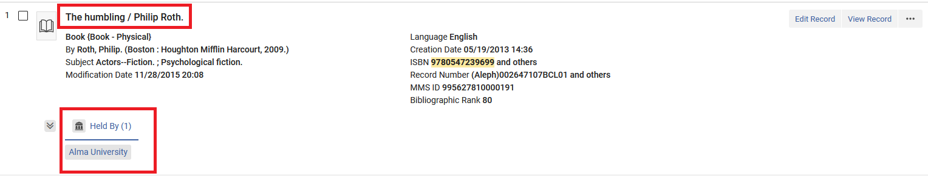
Here is the “second” record in the Member Institution “Open University” (note that because it is not linked to the Network Zone it does not have an icon indicating that it is linked to the Network Zone):
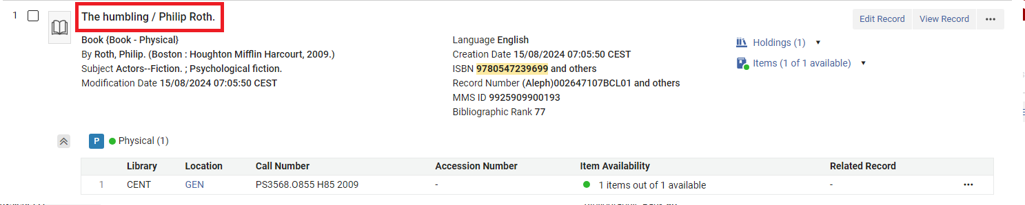

Note: In all the steps below, we are in the Member Institution “Open University”.

A short, abridged version
- In the Metadata Editor open the record which you want to merge with the Network Zone record.
- In the Metadata Editor do menu option “Record Actions > Share with Network”.
- If a dialog box “Confirmation Required” appears with text “Matched record/s exist in the catalog, do you want to view them before saving?” click “No”
- Take note that the record gets linked to the Network Zone institution and see a Network Zone icon for the record in the Metadata Editor navigation pane
- Release all records from the Metadata Editor
- Reopen in the Metadata Editor the record which we just now shared with the Network Zone (which is the record we want to merge with the pre-existing record in the Network Zone).
- In the Metadata Editor switch to “Editor Split Mode” and click in the right pane so that this will be the “in focus” pane for a future activity.
- In the Network scope search for the pre-existing Network Zone record (record to be merged with) and click Edit Record.
- In the Metadata Editor choose menu option “Record Actions > Merge & Combine”.
- In the “Merge Records & Combine Inventory” dialog box select the desired Merge Routine. This may be a specific routine agreed upon by your Consortia.
- In the “Merge Records & Combine Inventory” dialog box scroll down and for the secondary record select “Delete” and click “OK”
- In the Metadata Editor release the records from the left pane
- We have completed the process. Now if you search the in the Member Institution in either the Institution scope or the Network scope there will be only one record.

A detailed version including in-depth explanations as well as explanatory screenshots
- In the Metadata Editor open the record which you want to merge with the Network Zone record. Search for it in the Institution Scope and click “Edit Record”. Note that there is no icon here indicating that it is shared with the Network Zone institution, so you are sure that it is not already shared with the Network Zone institution.
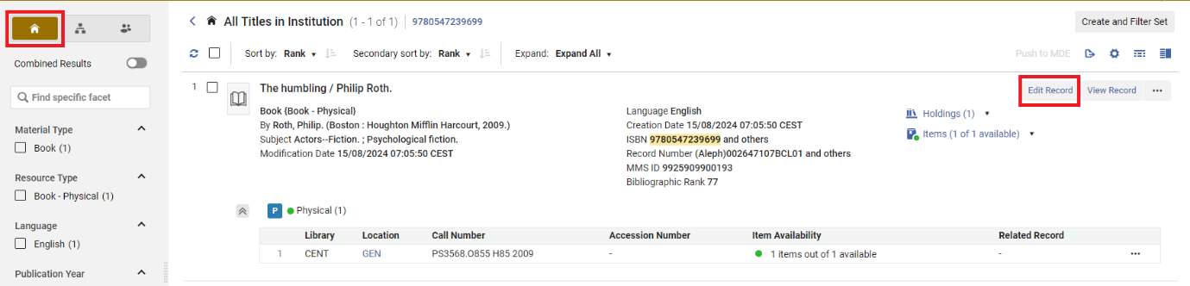
- In the Metadata Editor do menu option “Record Actions > Share with Network”. Note also that in the Metadata Editor there is a house icon indicating that this record is “local” and thus not currently shared with the Network Zone institution.
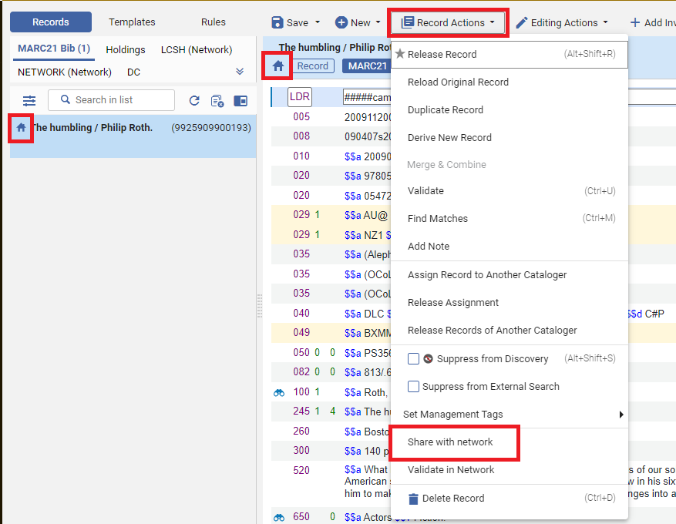
- If a dialog box “Confirmation Required” appears with text “Matched record/s exist in the catalog, do you want to view them before saving?” click “No”
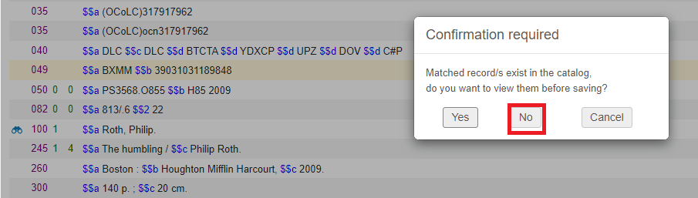
- Take note that the record gets linked to the Network Zone institution and see a Network Zone icon for the record in the Metadata Editor navigation pane.
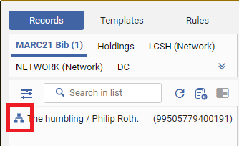
- Release all records from the Metadata Editor
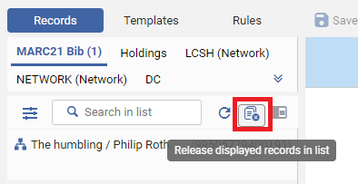
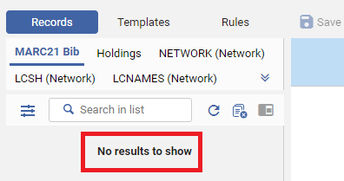
- Reopen in the Metadata Editor the record which we just now shared with the Network Zone (which is the record we want to merge with the pre-existing record in the Network Zone). Search for it again in the Institution Scope and click “Edit record”. Note also that now it has an icon indicating that it is linked to the Network Zone (this is because we did “Share with Network”)
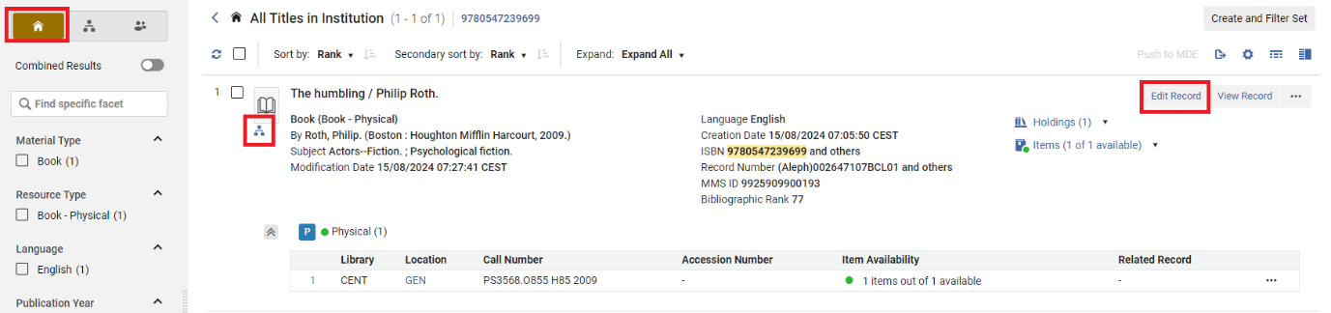
- In the Metadata Editor switch to “Editor Split Mode” and click in the right pane so that this will be the “in focus” pane for a future activity. You now have the record which we just shared with the network open and another pane which is in focus.
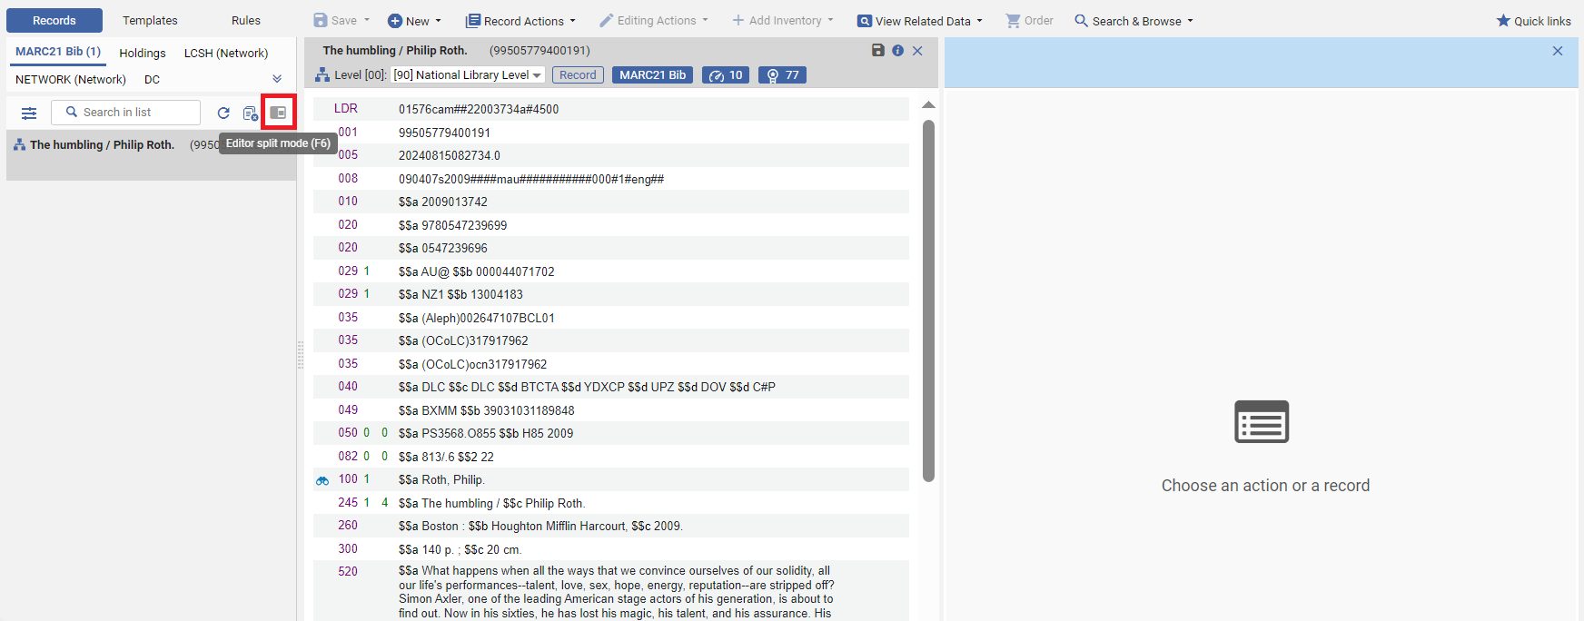
- In the Network scope search for the pre-existing Network Zone record (record to be merged with) and click Edit Record. It will appear in the right pane (which we previously clicked in to make it “in focus”). In the left pane we have the record with which we just did “share with network” and in the right pane we have the record which already existed in the NZ.
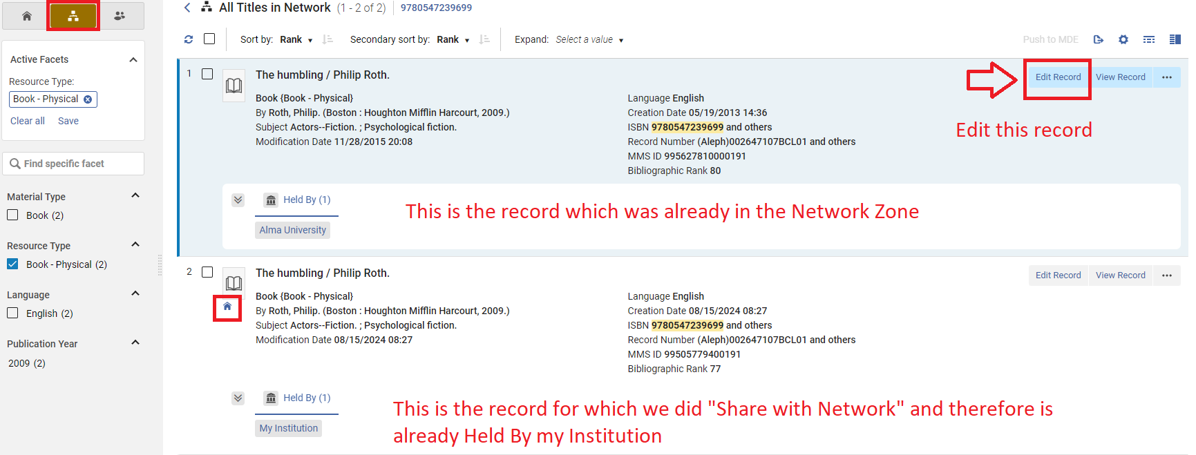
Now both Network Zone records are open in the Metadata Editor, and we will merge them
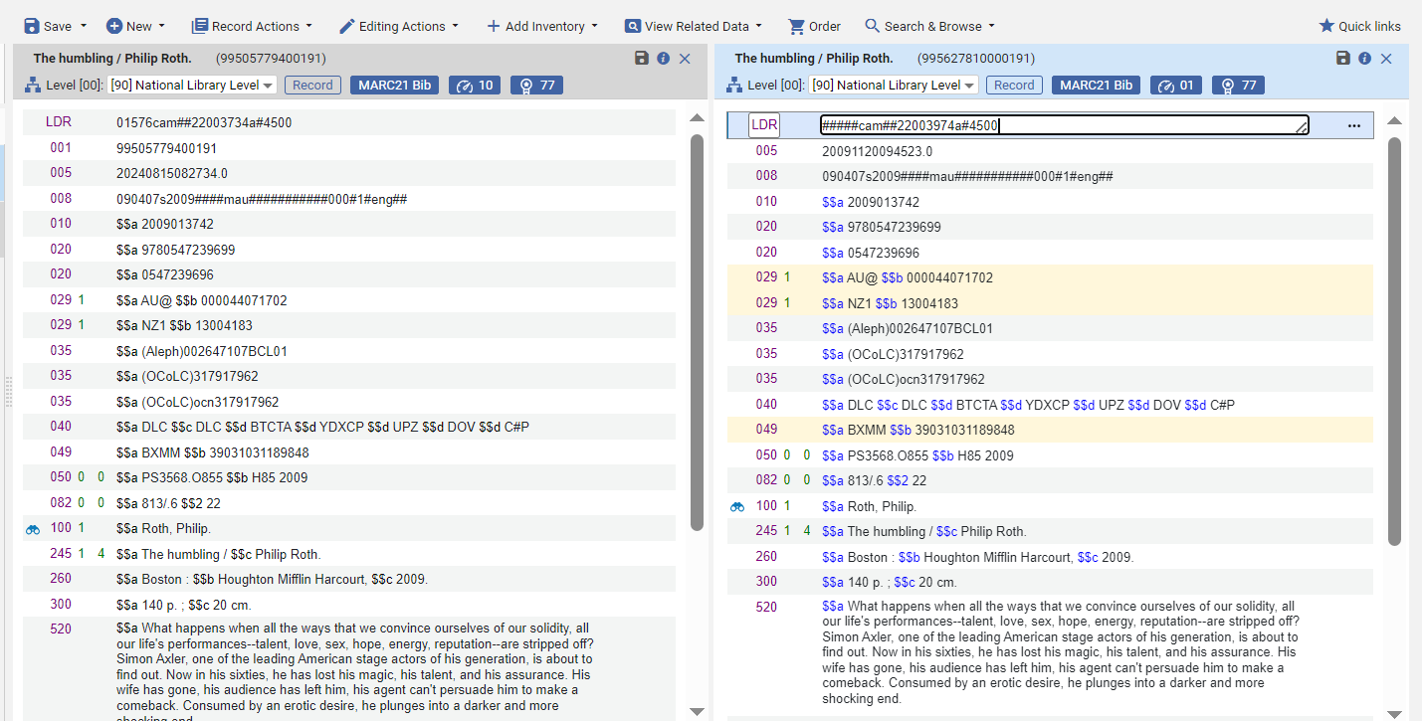
- In the Metadata Editor choose menu option “Record Actions > Merge & Combine”.
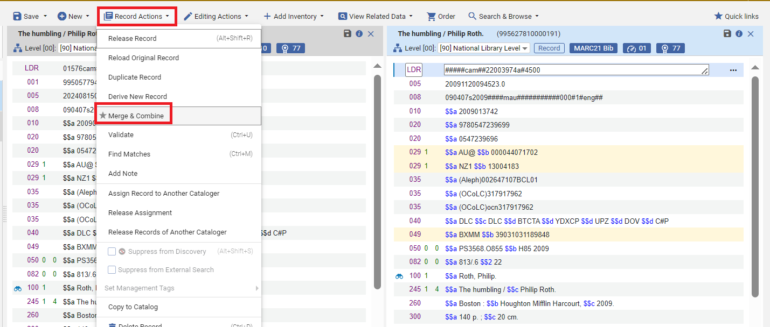
- In the “Merge Records & Combine Inventory” dialog box select the desired Merge Routine. This may be a specific routine agreed upon by your Consortia.
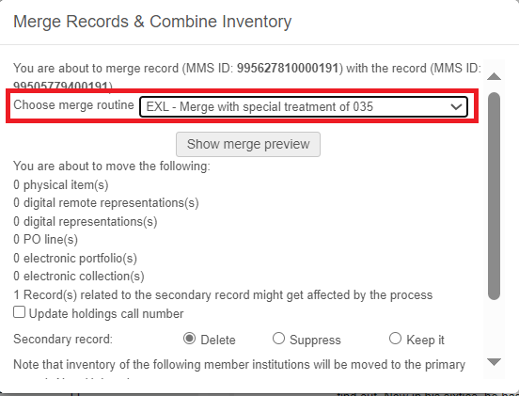
- In the “Merge Records & Combine Inventory” dialog box scroll down and for the secondary record select “Delete” and click “OK”
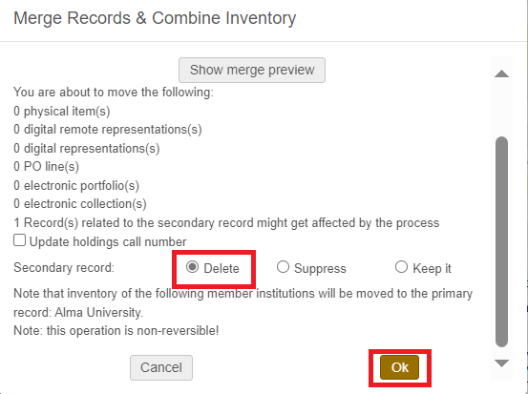
- In the Metadata Editor release the records from the left pane
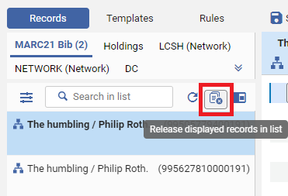
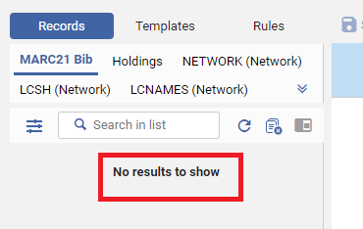
- We have completed the process. Now if you search the in the Member Institution in either the Institution scope or the Network scope there will be only one record. This one (merged) record will be “Held By” your institution as well as any institution(s) which the merged record was already “Held By”.
Here is a search in the Network scope:
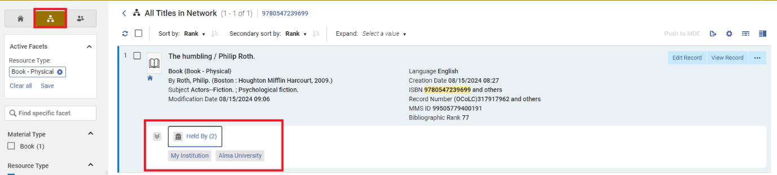
Here is a search in the Institution scope:
